Activity 1. Some iterative models

|  |  |  |  |  |
| --- | --- | --- | --- | --- |
| N | tLoop1 (mS) | tLoop2 (mS) | tLoop3 (mS) | tLoop4 (mS) |
| 100 | 0.00678 | 0.167 | 0.797 | 0.641 |
| 200 | 0.01204 | 0.604 | 3.544 | 4.574 |
| 400 | 0.03165 | 2.790 | 14.667 | 34.8 |
| 800 | 0.06850 | 13.127 | 62.9 | 268.1 |
| 1600 | 0.17307 | 49.6 | 263.4 | 2120 |
| 3200 | 0.35820 | 224.7 | 1120.2 | 16724 |
| 6400 | 0.726 | 894.5 | 4681.9 | 133836 |
| 12800 | 1.544 | 4098 | 19612 | OoT |
| 25600 | 3.143 | 18001 | 82583 | OoT |
| 51200 | 6.303 | 71268 | 337330 | OoT |

tLoop1 grows O(n*log(n))

tLoop2 grows O(n2*log(n))

tLoop3 grows O(n2*log(n))

tLoop4 grows O(n3)

Activity 2. Iterative models of a given time complexity

|  |  |  |  |
| --- | --- | --- | --- |
| N | tLoop5 (mS) | tLoop6 (mS) | tLoop7 (mS) |
| 100 | 4.07 | 52.10 | 386.8 |
| 200 | 19.55 | 447 | 6199 |
| 400 | 92.70 | 3863 | 98658 |
| 800 | 434 | 32395 | OoT |
| 1600 | 2017 | OoT | OoT |
| 3200 | 9292 | OoT | OoT |
| 6400 | 41805 | OoT | OoT |

Loop5: O(n2 log2n), Loop6: O(n3 log n), Loop7: O(n4)

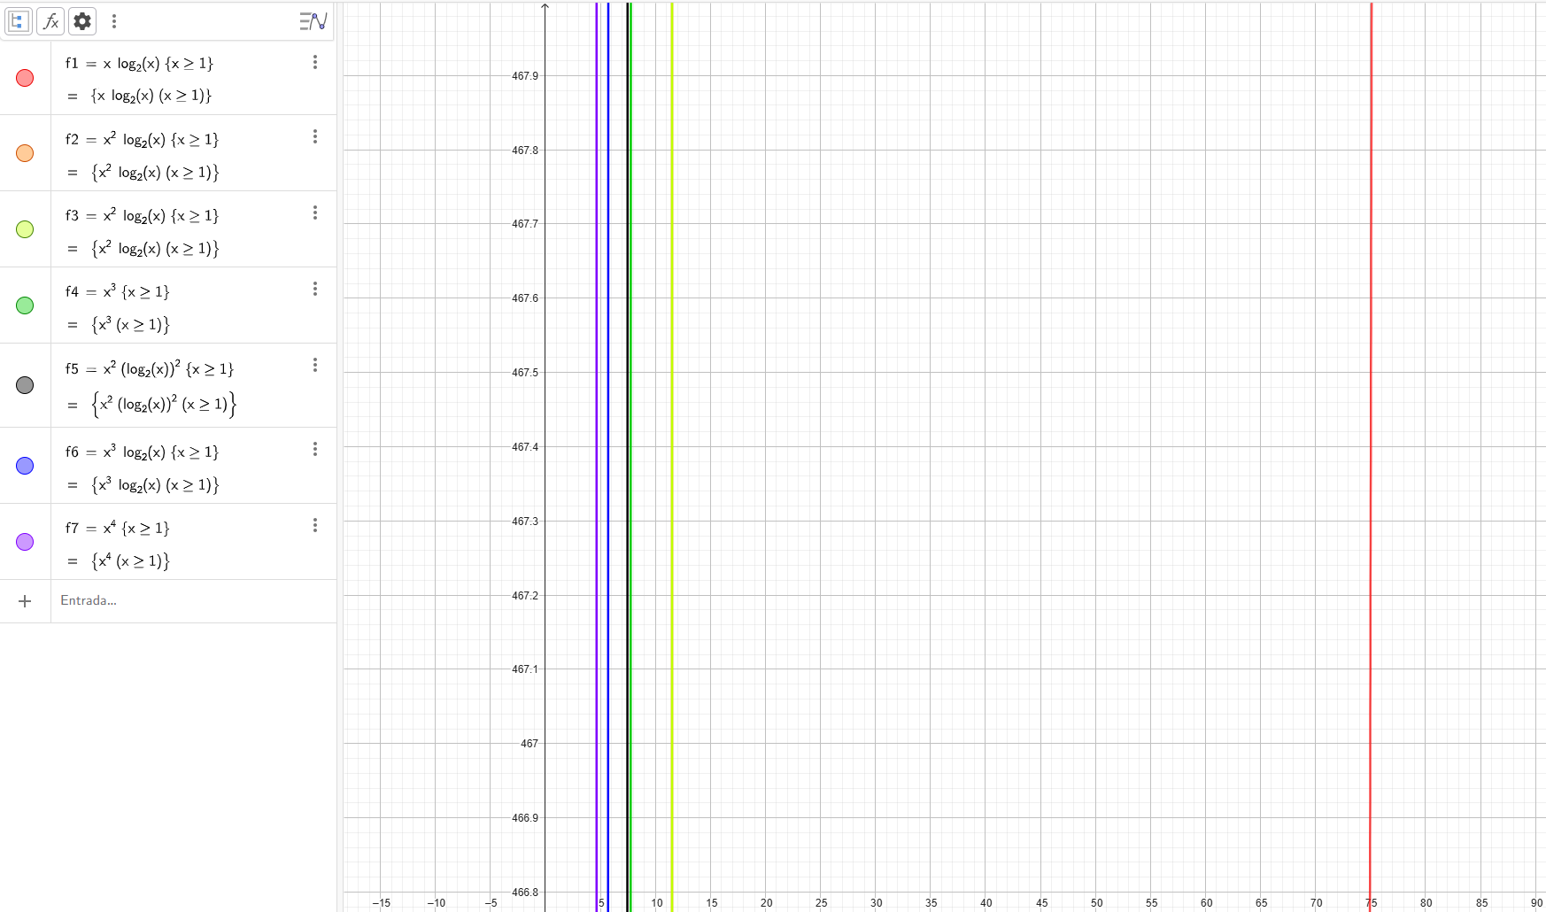

As you can see, if the fline is more near the zero, means that it grows more that the others that are more on the right.

Activity 3. Compare t1 and t2

|  |  |  |  |
| --- | --- | --- | --- |
| N | tLoop1 (mS) | tLoop2 (mS) | t1 / t2 |
| 100 | 0.00678 | 0.167 | 0.0406 |
| 200 | 0.01204 | 0.604 | 0.0199 |
| 400 | 0.03165 | 2.790 | 0.0113 |
| 800 | 0.06850 | 13.127 | 0.0052 |
| 1600 | 0.17307 | 49.6 | 0.0035 |
| 3200 | 0.35820 | 224.7 | 0.0016 |
| 6400 | 0.726 | 894.5 | 0.0008 |
| 12800 | 1.544 | 4098 | 0.0004 |
| 25600 | 3.143 | 18001 | 0.0002 |
| 51200 | 6.303 | 71268 | 0.0001 |

The Loop1 is less complex than the Loop2 as it tends to 0 (t1/t2)

Activity 4. Compare t2 and t3

|  |  |  |  |
| --- | --- | --- | --- |
| N | tLoop2 (mS) | tLoop3 (mS) | t2 / t3 |
| 100 | 0.167 | 0.797 | 0.2095 |
| 200 | 0.604 | 3.544 | 0.1704 |
| 400 | 2.790 | 14.667 | 0.1902 |
| 800 | 13.127 | 62.9 | 0.2087 |
| 1600 | 49.6 | 263.4 | 0.1883 |
| 3200 | 224.7 | 1120.2 | 0.2006 |
| 6400 | 894.5 | 4681.9 | 0.1911 |
| 12800 | 4098 | 19612 | 0.2090 |
| 25600 | 18001 | 82583 | 0.2180 |
| 51200 | 71268 | 337330 | 0.2113 |

The Loop2 has the same complexity than the Loop3 as neither goes to 0 nor infinity (t2/t3)

Activity 5. Different environments

|  |  |  |  |  |  |
| --- | --- | --- | --- | --- | --- |
| N | L4 PY (mS) | L4 JWN (mS) | L4 JW (mS) | JWN / PY | JW/JWN |
| 200 | 24 | 4.574 | 0.84 | 0.1906 | 0.1836 |
| 400 | 100 | 34.8 | 4.97 | 0.3480 | 0.1428 |
| 800 | 1600 | 268.1 | 30.65 | 0.1676 | 0.1143 |
| 1600 | 13000 | 2120 | 205.98 | 0.1631 | 0.0972 |
| 3200 | 123000 | 16724 | 1396.8 | 0.1360 | 0.0835 |
| 6400 | OoT | 133836 | 11116 | - | 0.0831 |

As is the same algorithm, all the divisions show a similar result, as it compares the algorithm not the machine that runs it.